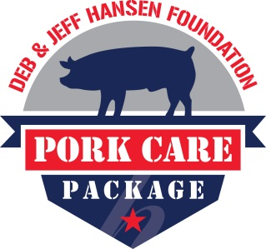
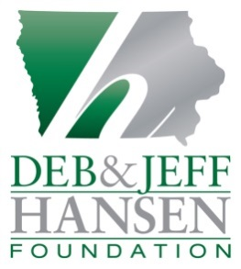
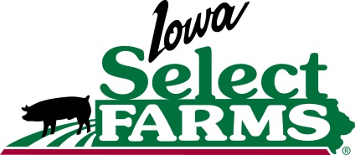

December 13, 2016
For Immediate Release

Contact:
Jen Sorenson
Iowa Select Farms
Cell: 641-373-4534
jsorenson@iowaselect.com

Iowa Select Farms, Deb & Jeff Hansen Foundation
Send Pork Care Packages Statewide to Iowa Members of the Armed Services
Iowa members of the Armed Services and their families will have a little more on their plates this holiday season, quite literally, with a donation of Pork Care Packages from the Deb and Jeff Hansen Foundation and Iowa Select Farms. Every member of all Iowa military units will be receiving $38 worth of coupons good for various pork products, including fresh pork, ham, ribs, bacon and ground pork, through their unit’s Family Readiness Coordinators. In total, more than 12,000 service members across Iowa will be receiving the coupons, equating to $456,000 in free pork.

“Providing support to military families is the least we can do for those on active duty and those who dedicate their time to serving our country,” said Jeff Hansen, President and CEO of Iowa Select Farms and co-founder of the Deb and Jeff Hansen Foundation. “Supplying the resources for several home-cooked meals to help bring families together is our way of saying ‘thank you’ to the men and women who sacrifice so much of their time away from their loved ones.”

Employees of Iowa Select Farms delivered the Pork Care Packages to all units of the Iowa National Guard, along with the 132nd Fighter Wing, Iowa Air National Guard; 185th Air Refueling Wing, Iowa Air National Guard; US Army Reserves; US Navy Reserves and US Marine Corps Reserves. Pork Care Packages were also delivered to the Iowa National Guard’s Survivor Outreach Services to deliver to 600 Iowa families of fallen Soldiers.

“We receive a tremendous response from military families about the Pork Care Packages,” said Jen Sorenson, Communications Director for Iowa Select Farms. “They enjoy being able to pick up their ‘tried and true’ cuts from the meat case and we also hear back from families who got creative with the coupons and experimented with a new pork product. But above it all, we hear time and time again that their families had a great reason to come together for a good meal.”

From ribs and bacon to fresh pork, the coupons in the Pork Care Packages are redeemable at any local grocery store, regardless the brand or cut. For three years in a row the Deb and Jeff Hansen Foundation has provided the Pork Care Packages to show gratitude to military families, and this year the coupons were accompanied by a useful “Grocery Buddy” notepad featuring a prepopulated grocery lists where shoppers can check off the items they need to purchase.

Founded in 2006, the Deb and Jeff Hansen Foundation facilitates programs throughout Iowa focused on providing hunger relief, showing gratitude to members of the Armed Services and supporting families impacted by childhood cancer. Jeff and Deb Hansen are the owners of Iowa Select Farms, a privately-owned, Iowa-based pork production company with 1,400 employees and contractors.

###

Caption #1 (Jen Sorenson and Allyson Ladd in front of Pork Care Package boxes)
Volunteer groups and employees of Iowa Select Farms organized and delivered Pork Care Packages to all units of the Iowa National Guard, along with the 132nd Fighter Wing, Iowa Air National Guard; 185th Air Refueling Wing, Iowa Air National Guard; US Army Reserves; US Navy Reserves and US Marine Corps Reserves. The Pork Care Packages were also delivered to nearly 600 Iowa families supported by the Iowa National Guard’s Survivor Outreach Services. Pictured left to right – Allyson Ladd and Jen Sorenson, representatives of the Deb and Jeff Hansen Foundation and Iowa Select Farms.

Caption #2 (Fresh pork with coupons)
The Pork Care Packages provided by the Deb and Jeff Hansen Foundation and Iowa Select Farms include $38 worth of coupons redeemable at any grocery store, totally a donation of $456,000. The coupons are good for any brand or cut of pork products, including fresh pork, ham, ribs, bacon and ground pork.

